Data Management and Organization
DTSC6002001 – LC09 – LEC

Name : Wilbert Chandra
NIM : 2602113666

Soal GSLC Session 4
Silahkan selesaikan soal berikut dan Screenshotlah hasil yang diperoleh.

Problem 1
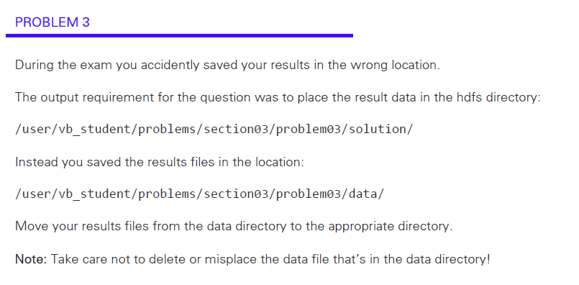

Solution :
- Use the ls function to find the filepath of the file that needs to be moved.
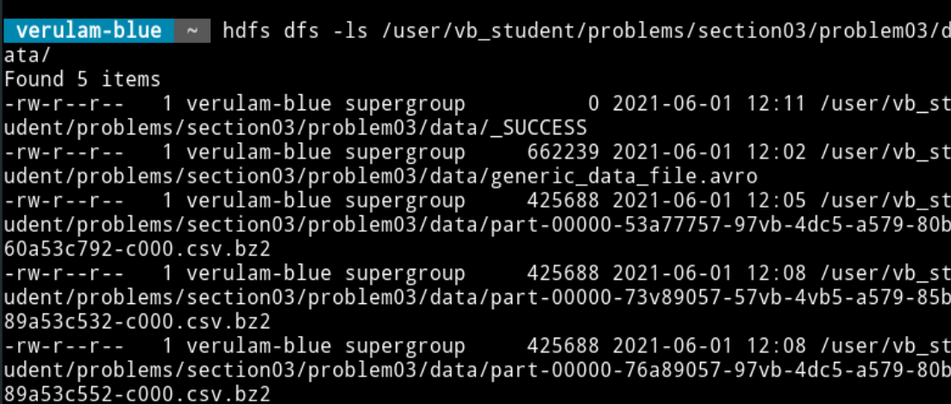
- Use the mv function to move the file
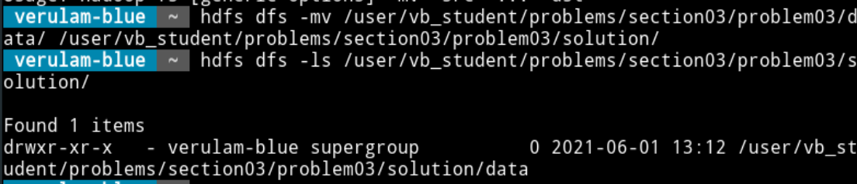

Problem 2
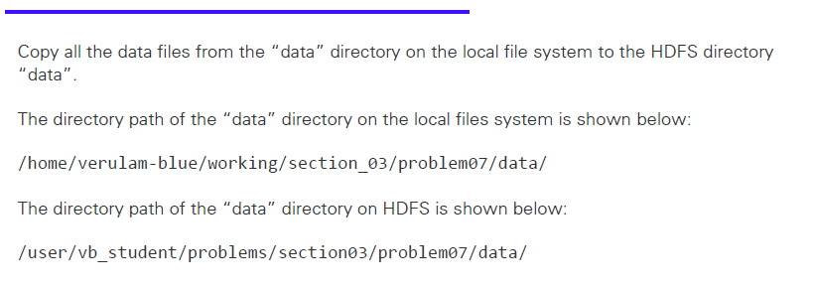

Use the put function to put the file from local to hdfs
